** **

**Documentation about the running of MOVSIM**

**Instructor**

**Mian Muhammad Mubasher**

**Made By**

**MUHAMMAD UMAIR RAUF (BSEF13A055)**

**MUHAMMAD MOEEN SANAULLAH (BSEF13A030)**

1. Download **Eclipse IDE** from eclipse official website.  
   [**https://eclipse.org/downloads/**](https://eclipse.org/downloads/)



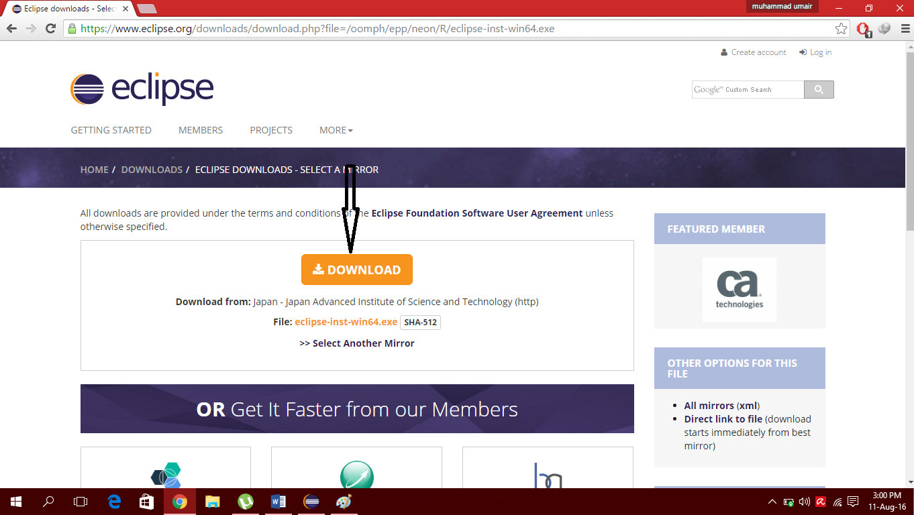

After downloading ,run installation EXE and select the following Eclipse IDE.

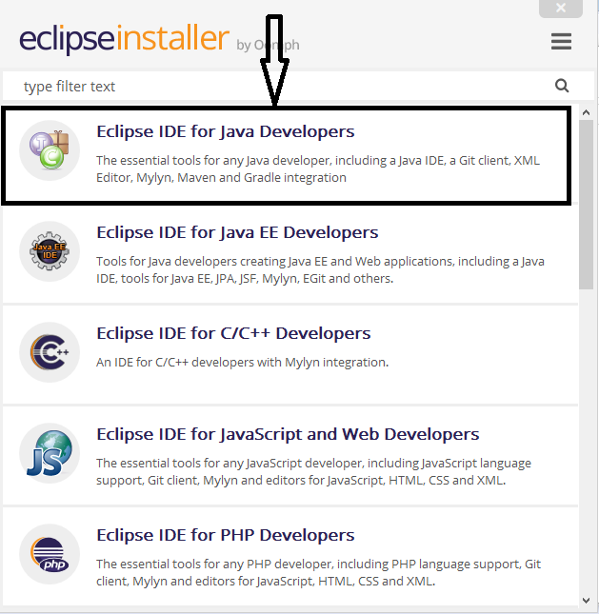

After complete installation of your Eclipse IDE for Java Developers. Create workspace of Eclipse in your computer where you want.

1. Download and Install **Tortoise Git**

[**https://tortoisegit.org/**](https://tortoisegit.org/)

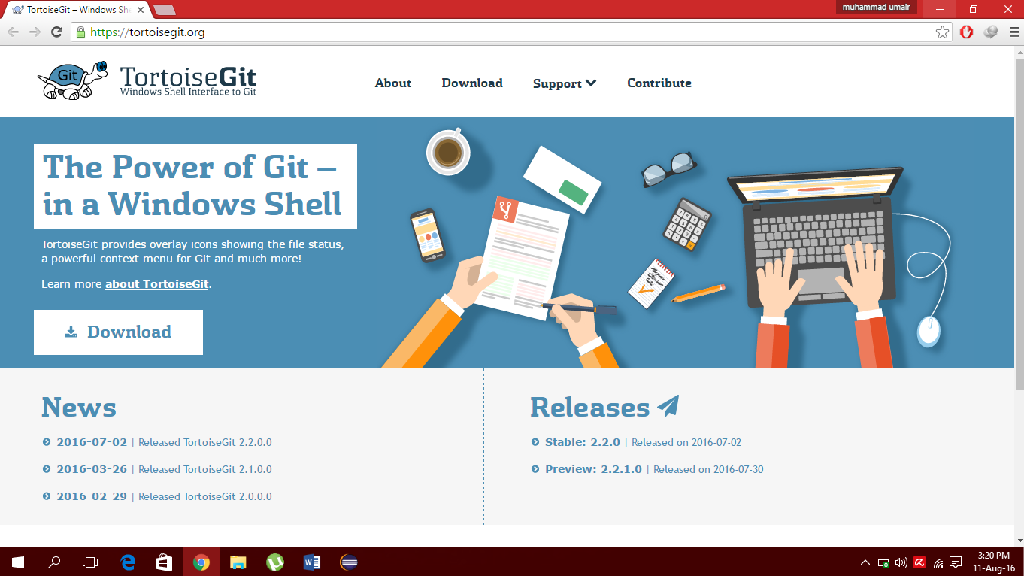

1. Clone **movsim** from **github**.

[**https://github.com/movsim/movsim**](https://github.com/movsim/movsim)

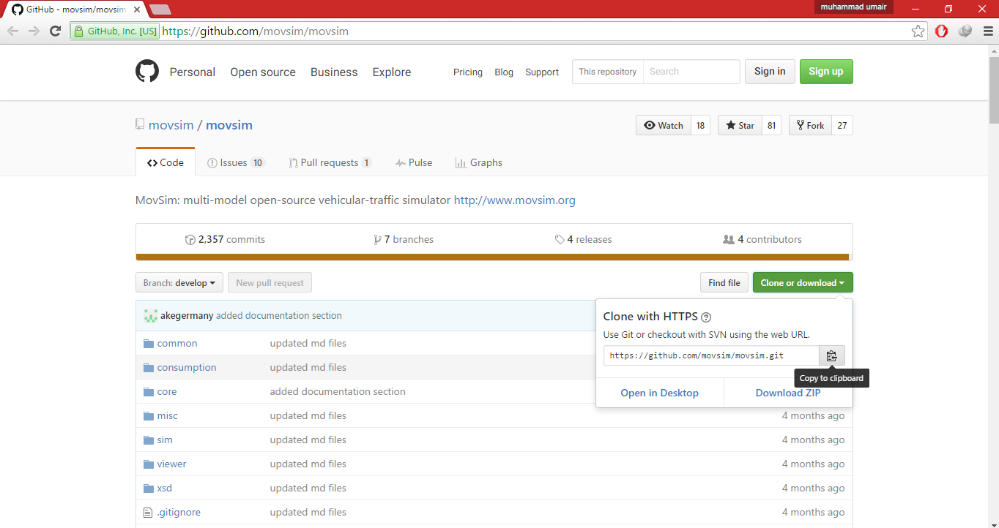

1. Click on **Clone or Download** and Copy to Clipboard this link, then go to the folder in your computer where you want to download **movsim**. Right click in that folder click

**Git Clone**

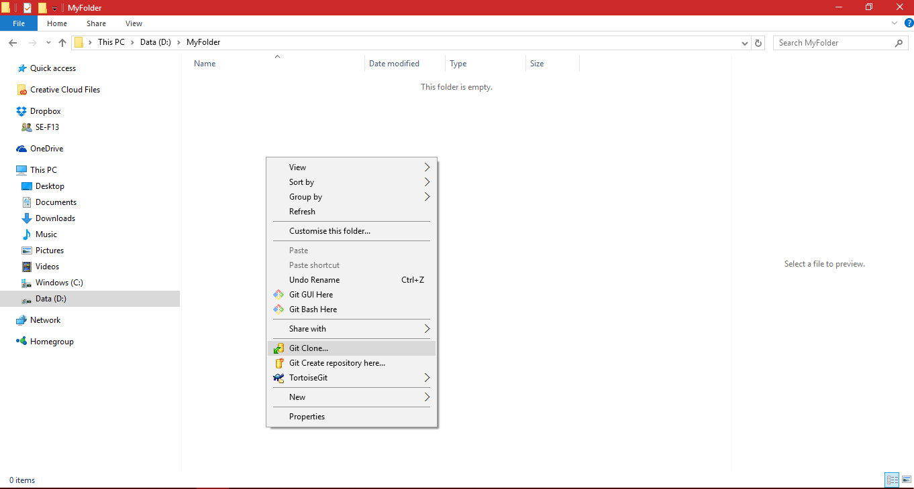

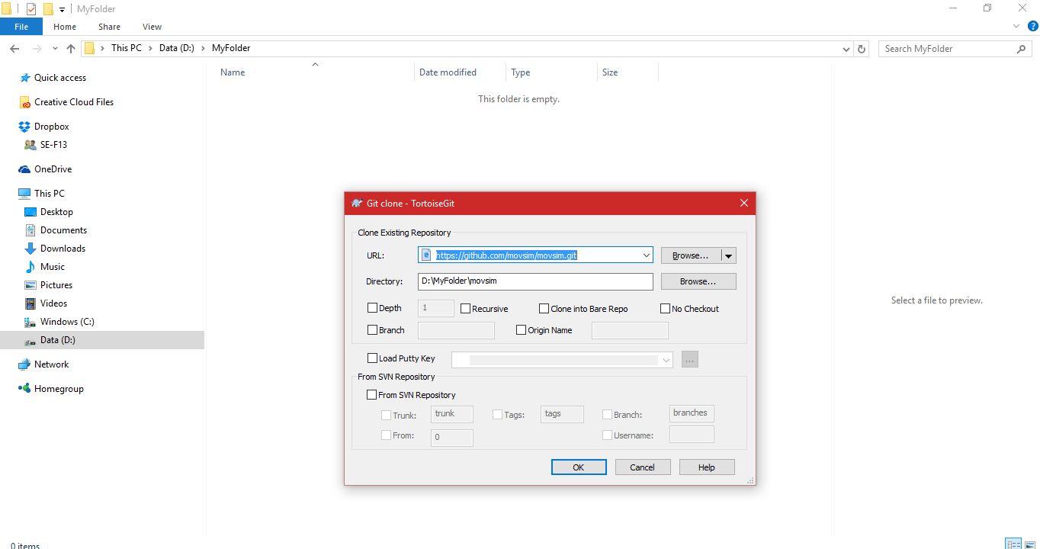

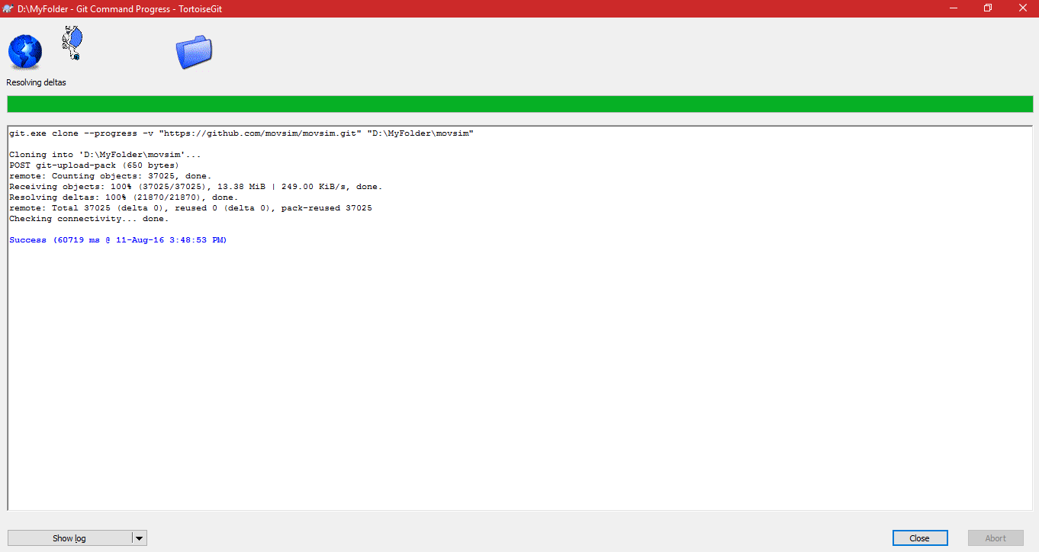

1. **movsim** now is in your folder.

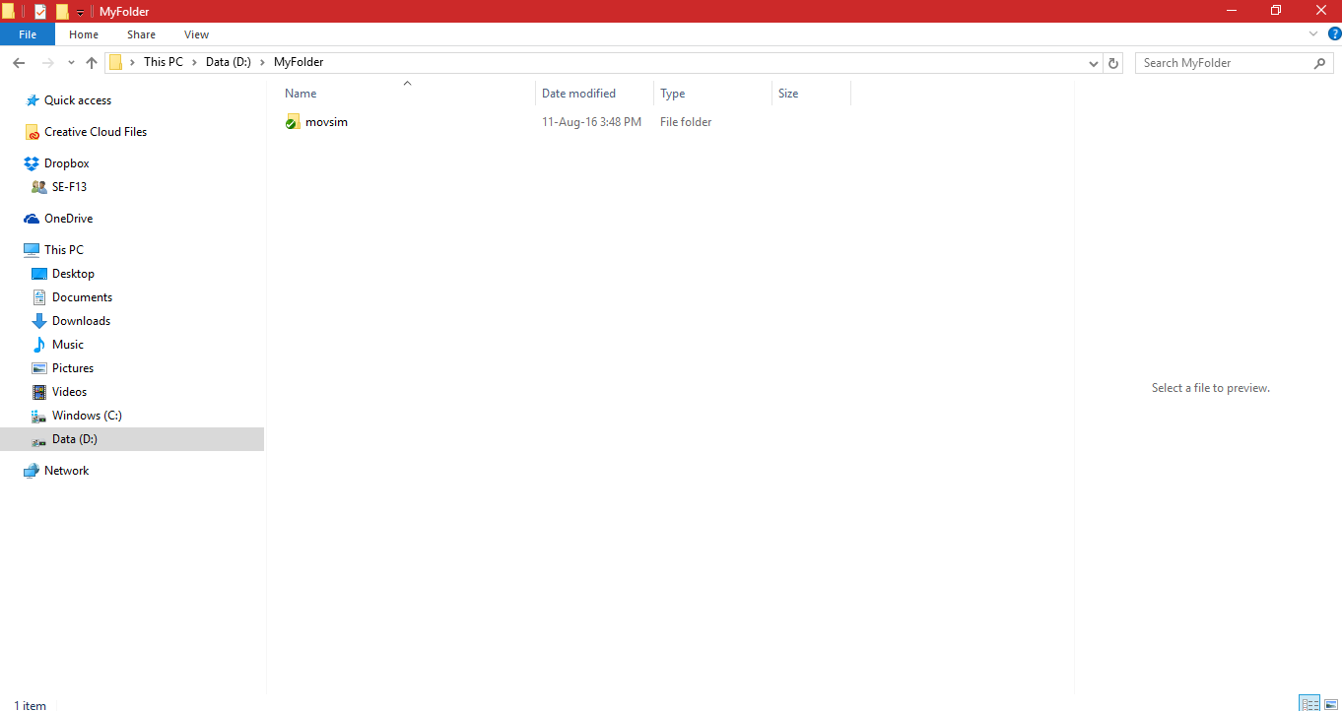

1. Launch **Eclipse** and go to **File->Import**, Click **Import**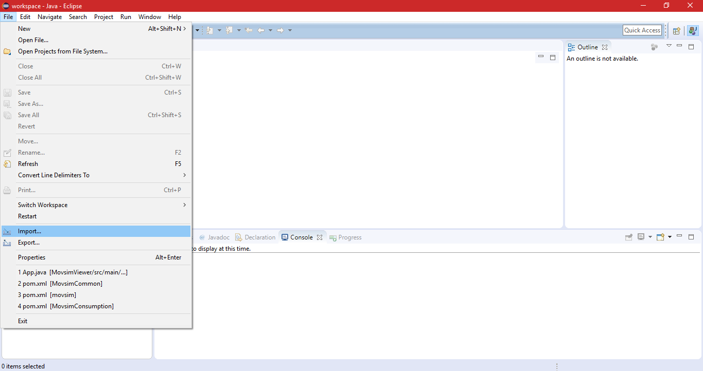
2. Go to **Maven** folder and scroll this you see the **Existing Maven Projects** click on this.

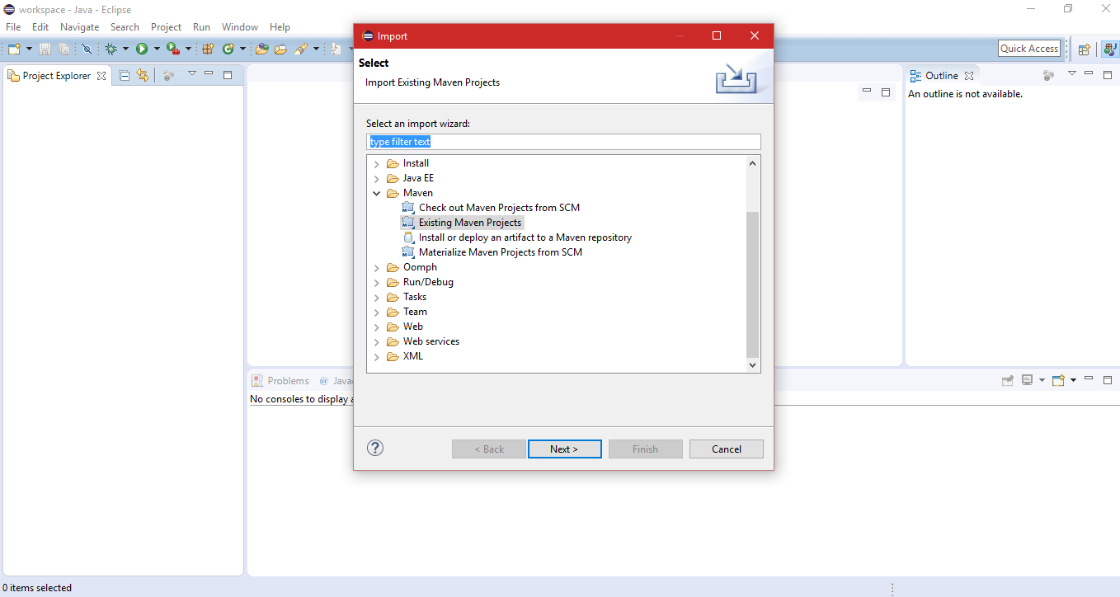

1. Click **Next** and import your **movsim** folder.

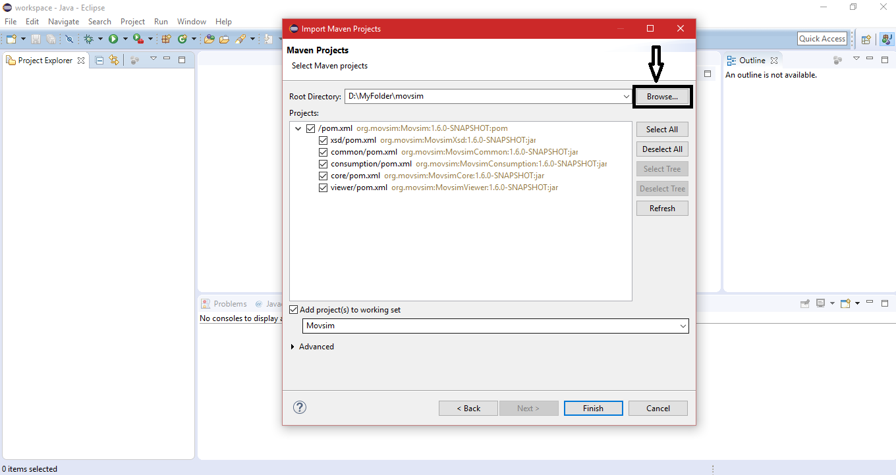

1. Click **Finish** you will see this.

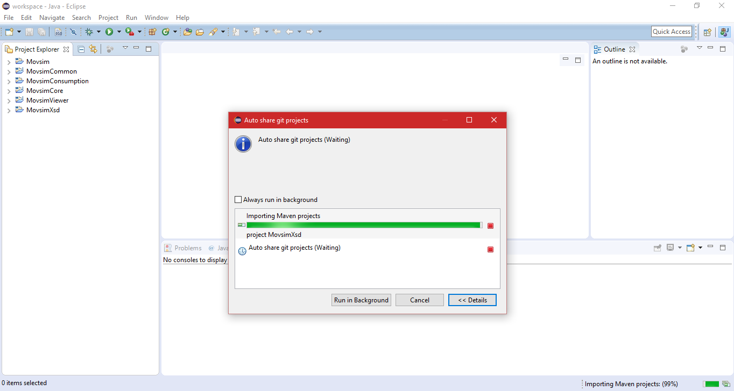

1. In case not working , go to project in status bar and click **Clean** project and **uncheck** the option **Build Automatically**.

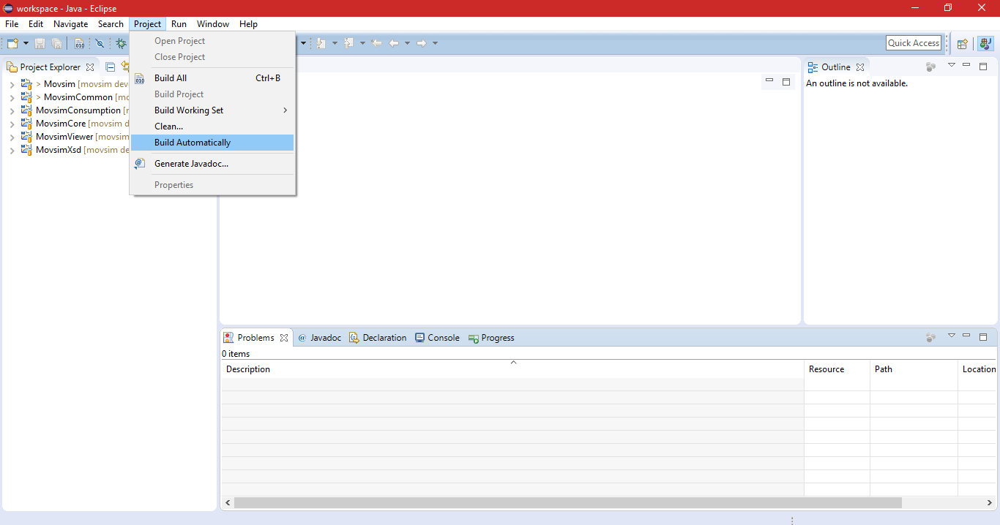

1. In the **Project Explorer** view you will see **App.java** under the **MovsimViewer** Run this one time.

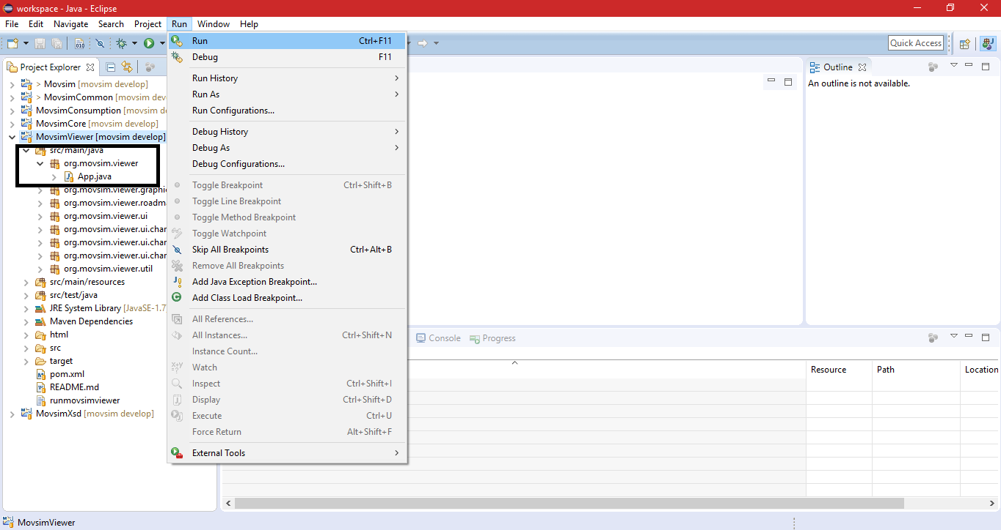

1. Go to **Run->Run Configuration** from menu bar. Click on **Run Configuration.**

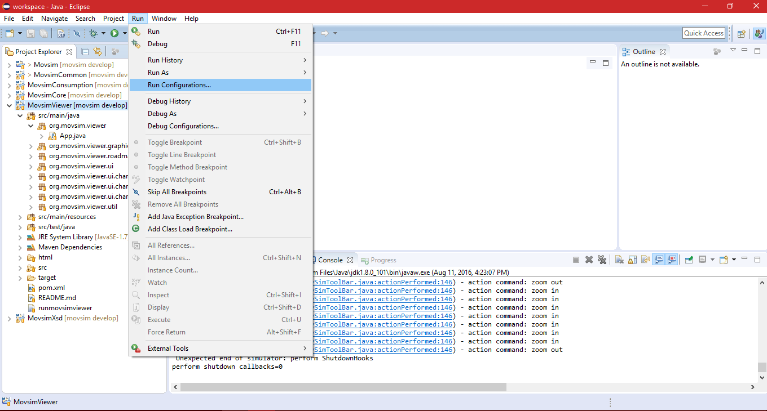

1. You will see **App** under the **Java Application** in your left pane. Click on **App**. You will see the **(x) = Argument** tab in your right pane.

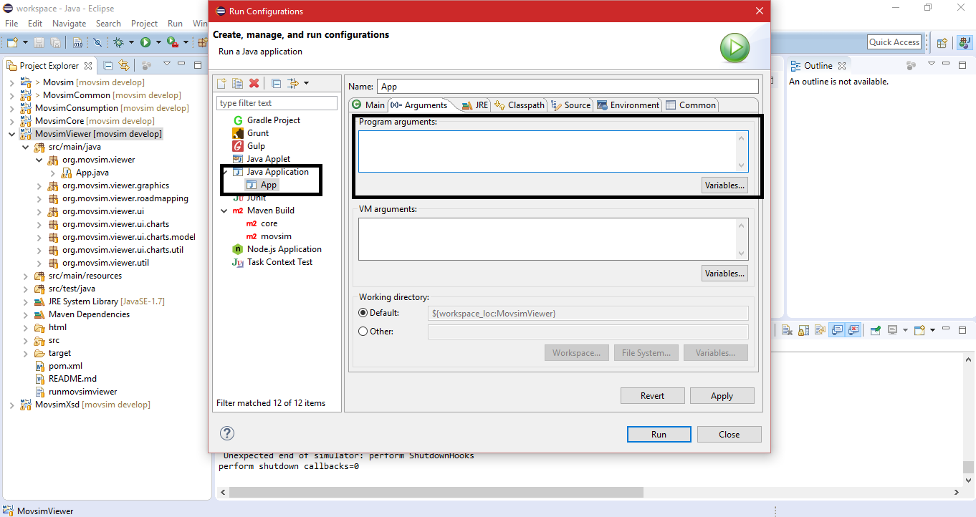

1. Now select path of the cloverleaf in the MOVSIM folder

**movsim->sim->buildingBlocks**You will see the **cloverleaf.xprj** in this folder. Copy this path.

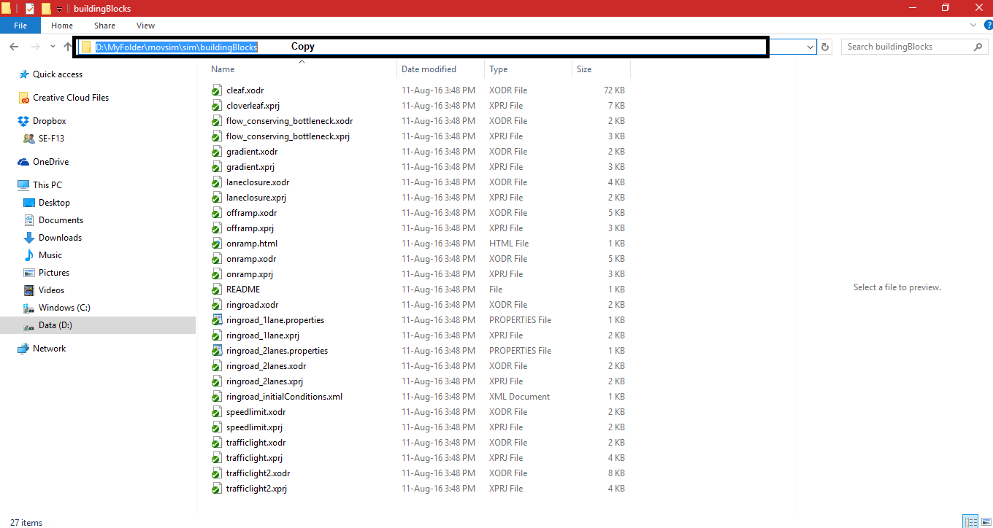

1. Now place this path in the text field of **Program arguments** in the **(x) = Argument tab**. Write **-f** in the start of the path with **(space)**.

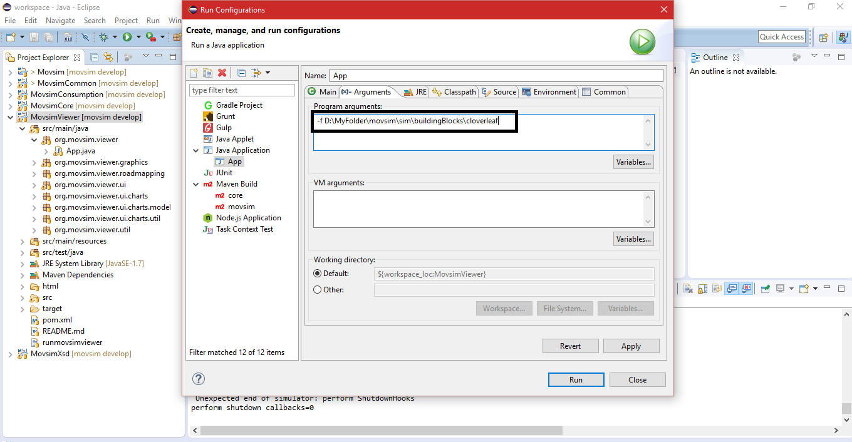

1. Click on **Apply**. Close the tab and **Run** the project from menu bar you will see the project like this.

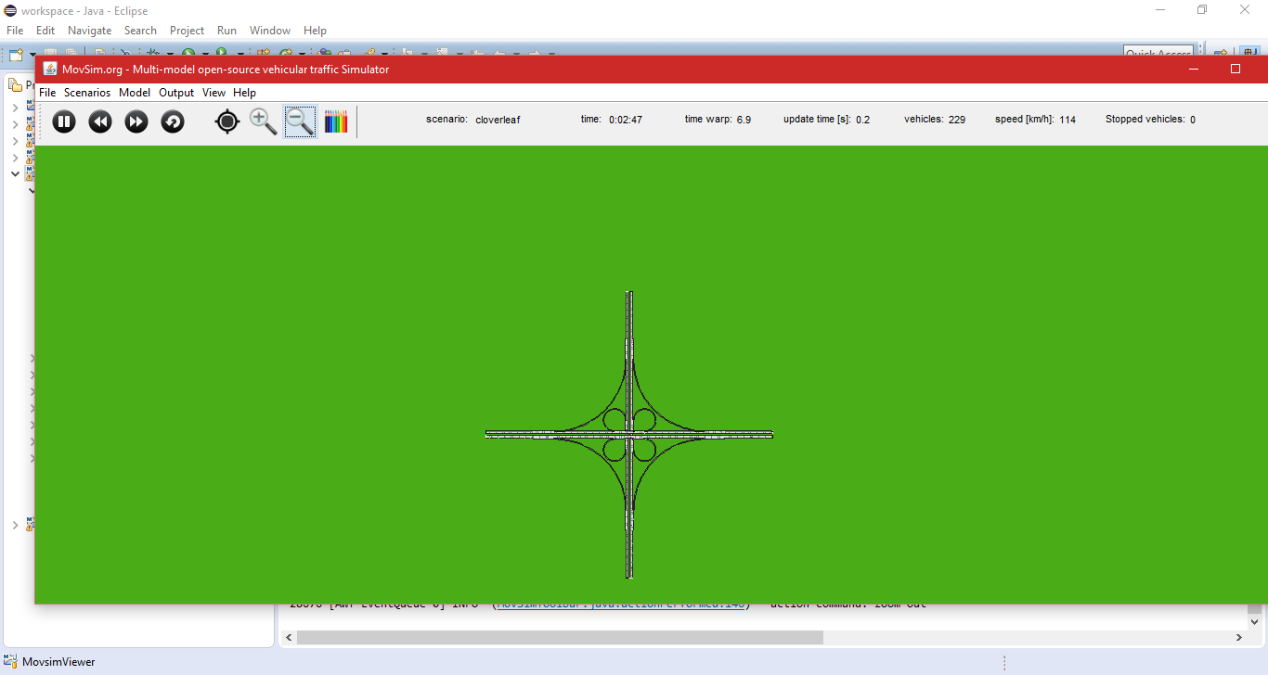

**If you will face more errors.  
1)** go to **Users/user** folder in your computer find **.m2** folder and delete the **repository** folder,

then download **movsim** again through **Git Clone** command as I discussed in **step 3,4,5** and repeat from **step 6**.

**2)** Make sure that you have installed **JRE** and **JDK** in your computer.

**3)** Make sure that you have installed **Maven Plugin** inyour Eclipse IDE. To check this whether it is installed or not, open your **Eclipse IDE.** Go to **Window->Preferences** from the menu bar of your **Eclipse IDE**.

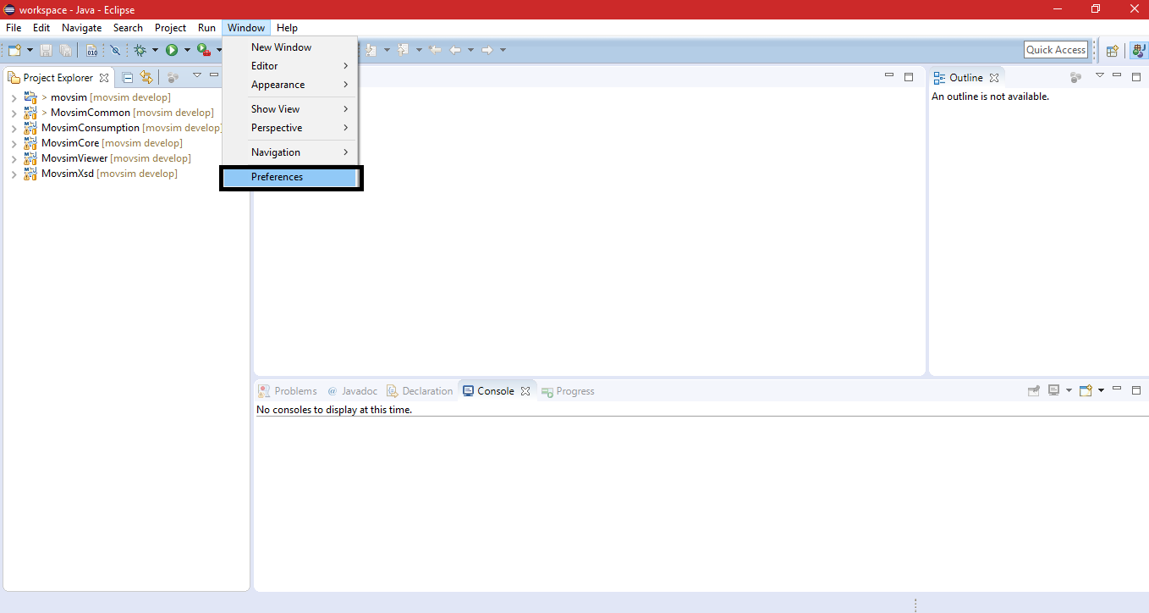

You will see the **Maven** in the left pane of your window. This means you have **Maven** installed in your **Eclipse IDE**.

